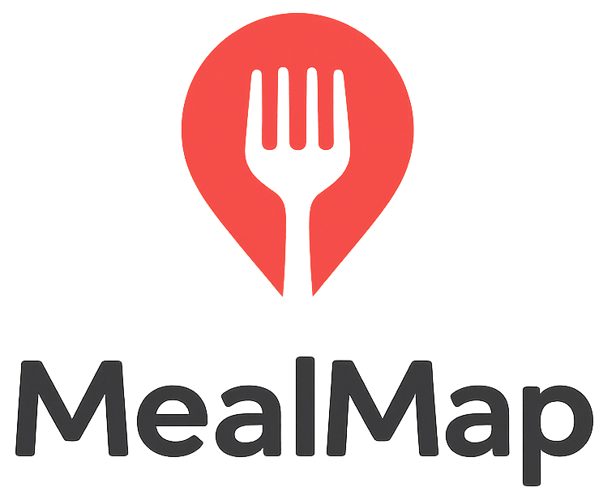
MealMap: Pitch Report

Problem Statement
International students at KAIST struggle to discover diet-relevant, trustworthy, and up-to-date food recommendations, both on campus and in the surrounding area, which consistently leads to missed culinary opportunities, limited cultural exchange, unpleasant surprises, and difficulties in adhering to dietary restrictions.

Solution
Our mobile app “MealMap” empowers international KAIST students to explore Korean food culture with confidence. The platform features peer-generated reviews tied to specific dishes, enriched with photos and detailed experiences, creating a reliable source of authentic dining knowledge. A machine learning system powered by user clusters continuously learns from preferences and behaviors, recommending restaurants and dishes that align with the tastes of similar users. This combination transforms scattered individual experiences into a dynamic, adaptive, and collective recommendation network for food. The more a student shares their own experiences, the better the system understands their preferences, thus making their recommendations sharper, more personal, and more valuable with every review. Built on familiar components such as map-based search, structured dietary filters, and lightweight user-clustering algorithms, the solution is technically realistic and scalable. By combining credible photo-backed reviews with personalized suggestions, the platform directly addresses both trust and dietary concerns in a way existing services fail to do.

Storyboard 1: Posting a review
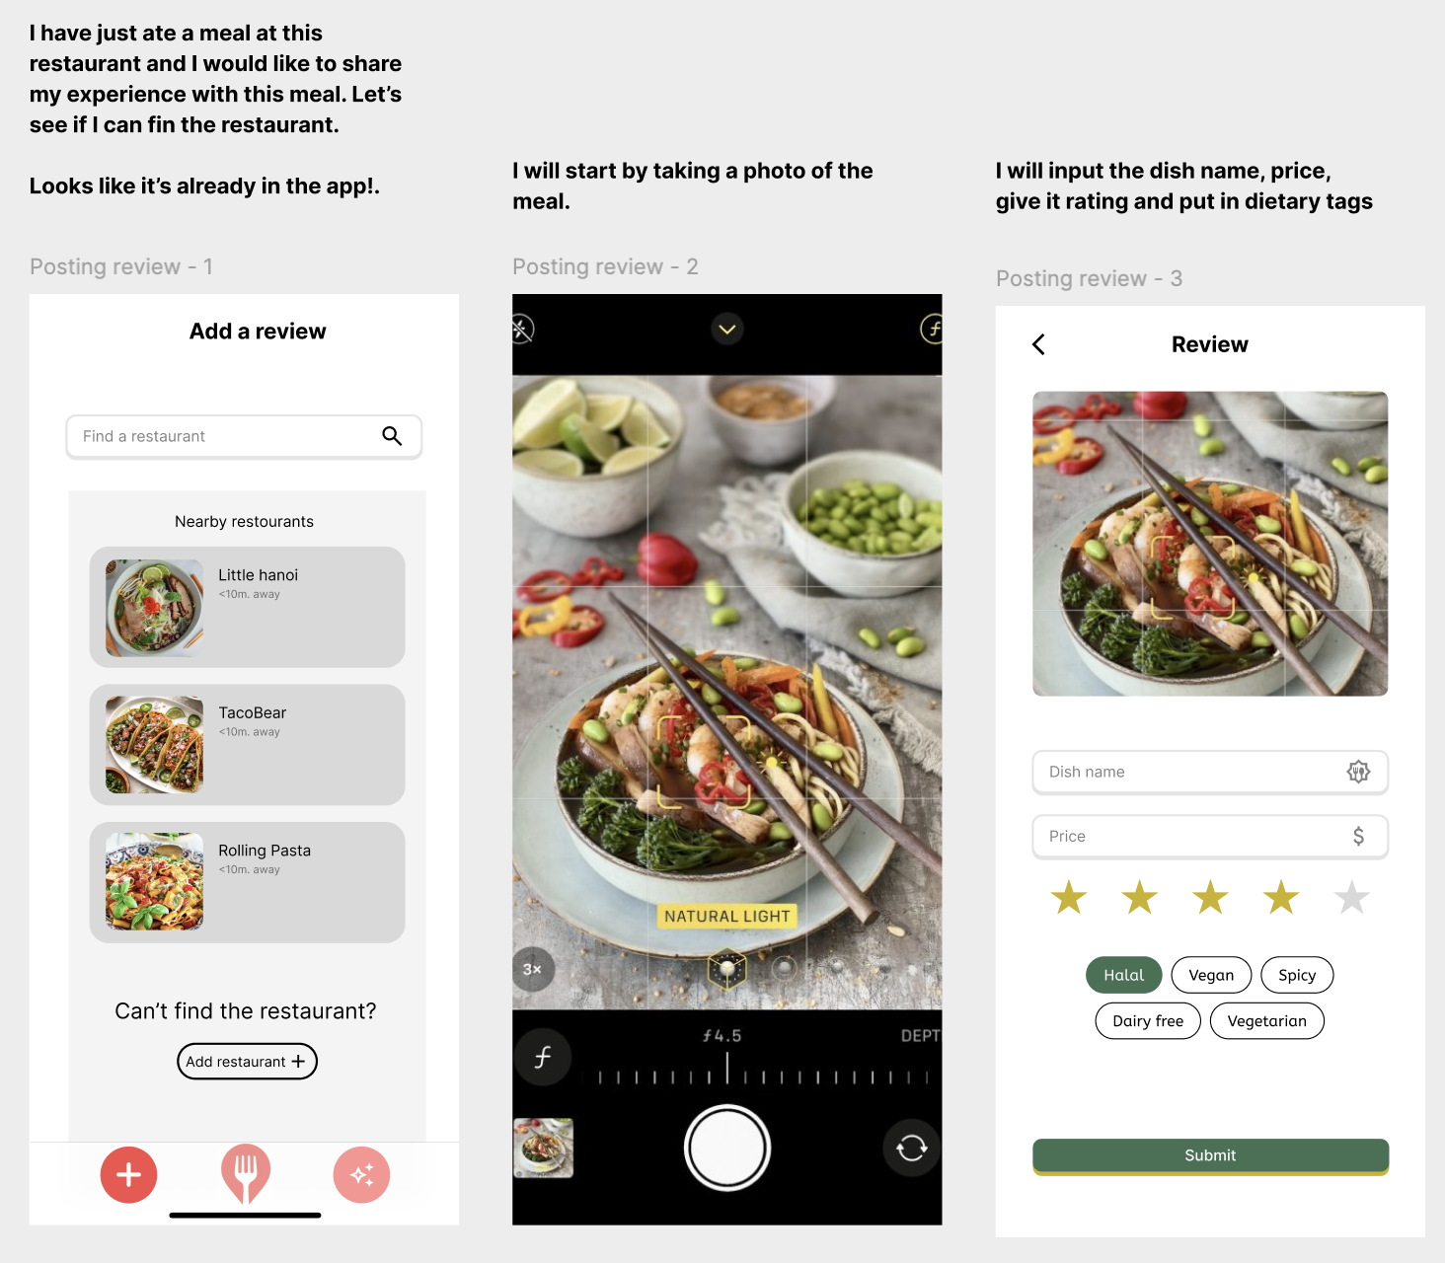
Storyboard 2+3: Recommendation Feed and Map Feature
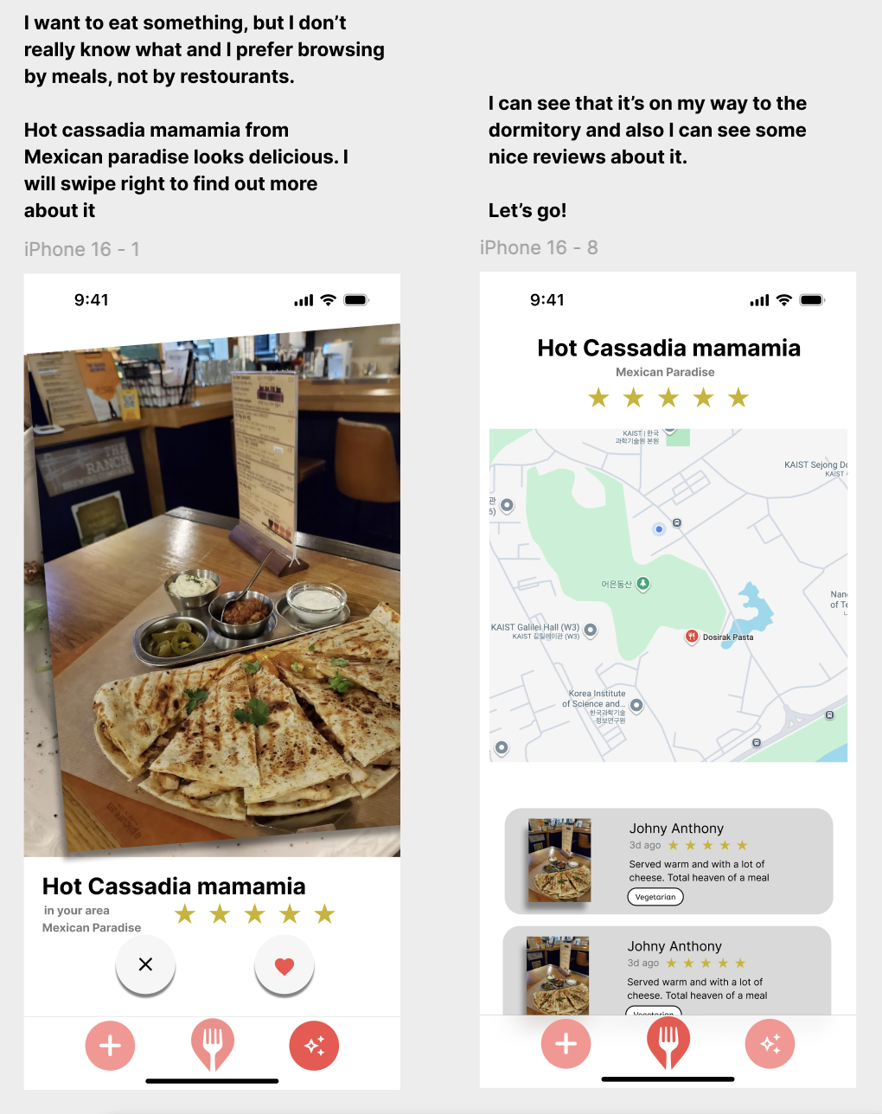
3 Core Tasks
Task 1: Post review of a meal
The user selects an existing place or adds a new one on the map. They go through a review form that prompts for inputs about various aspects of the food and attach an image.

This is core to the solution because it allows users to contribute meal reviews to the platform, which are critical for the platform to be useful. In addition to this, the visual element provides additional proof that the review left is real, increasing the credibility of the quality of food.

Task 2: Find a local and highly rated option that fits dietary needs
The user opens up a map and selects the required dietary needs, such as “vegan”, “non-spicy”, etc. from a list of dietary filters. Places with matching meals reported show up, showing the exact meals that fit the criteria. The user clicks on a place and can browse the reviews and information about these meals

This task is core because it directly addresses the user's need of finding dietary fitting meal options in the near area.

Task 3: Browse a particular restaurant to get and impression of its meals

The user searches or selects a particular restaurant on the map. They are presented with all reviews of the meals other people have reviewed, the dietary details about them and visual references.
This task is core as it addresses the need of the user to evaluate whether a restaurant in question is worth visiting and fits their needs.

Competitive Analysis

Naver Maps:
- Strengths: They are the undisputed leaders in Korea for location-based services. They have the most extensive database of restaurants, operating hours, and a massive volume of user reviews. They are essential for navigation.
- Weaknesses: The reviews are often in Korean and can be very brief. The rating system lacks nuance: It's hard to search for specific dishes or filter effectively by detailed dietary needs (e.g., "no pork," "truly vegetarian," "halal"). The sheer volume of information can be overwhelming.

Uber Eats:
- Strengths: A widely used application that due to being fully digital also has a high number of reviews left for different restaurants. It also has options of showing what other customers are currently buying, bringing popularity into the context of reviewing as well
- Weaknesses: Since the food is ordered, there are many aspects of the experience that are left out. This can include not only the experience of actually dining at the place, but also the difference in food quality after delivery. Additionally, prices can be different compared to real ones due to delivery costs or sale offers which might not be available in-person.

Restaurant menus:
- Strengths: As a direct source from the restaurant, menus provide official descriptions and impressions of each dish, often including ingredients, pricing, and basic visuals (e.g., photos in digital or printed formats). They are readily available on-site or via websites/apps, making them a quick reference for what's offered without needing third-party input.
- Weaknesses: Descriptions are typically promotional and lack depth, such as real-user photos, detailed experiences, or honest critiques (e.g., they rarely highlight potential issues like hidden allergens or taste surprises). They are almost never critical or objective, often omitting nuances for dietary restrictions (e.g., "truly vegetarian" vs. cross-contamination risks), and may not reflect actual quality or cultural context, leading to unpleasant surprises. As an indirect competitor, they don't facilitate peer reviews or personalized recommendations.

Feature | MealMap | Naver Maps | UberEats | Restaurant menus
Meal-Based Info | ✔︎ |  | ✔︎ | ✔︎
Map Functionality | ✔︎ | ✔︎ | Some
AI-Powered  Food Suggestions | ✔︎ |  | Some
Local Relevance (KAIST) | ✔︎ | ✔︎ |  | ✔︎
Detailed Dietary Filters | ✔︎ |  | Some | ✔︎
Frictionless & rich review process | ✔︎ | Some | ✔︎
Review Reliability | ✔︎
Order Food |  |  | ✔︎ | ✔︎

Timeline and responsibilities
